THE CRISIS AND MONETARY POLICY:
WHAT WE LEARNED
AND WHERE WE ARE GOING

By Dr Alan Bollard, Governor,
and Felix Delbruck, Economics Department,
Reserve Bank of New Zealand

A background paper for an address by Dr Bollard
to the Canterbury Employers’ Chamber of Commerce
Christchurch

29 January 2010
Embargoed to 1:00pm
- Introduction

Inflation targeting is a monetary policy framework that was developed in response to the high inflation and macroeconomic instability of the 1970s and 1980s. Twenty years ago, New Zealand was the first country to formally adopt key elements of this approach – such as an explicit inflation target and various accountability and monitoring structures - in the Reserve Bank Act 1989. The framework has been durable, even as we’ve continued to learn how the economy works and continued to adapt and refine the way we do monetary policy.

The past two decades have included one of the longest periods of growth that New Zealand has seen in decades, as well as droughts, migration shocks, terms of trade changes, an Asian crisis, a dot-com boom and bust, and, most recently, the worst global economic and financial crisis seen in generations. This speech looks back over those two decades of inflation targeting to see what lessons we can draw from these experiences, as well as outlining some of the challenges ahead.

- Assessing Two Decades of Learning

The framework we put in place in 1989 and refined in the following two decades has now been adopted in its main features by over 20 countries. In looking back, I will focus on the New Zealand experience, but the main conclusions I draw are not unique to New Zealand. I will argue that inflation targeting has done well on the price stability front, and has given central banks a lot of flexibility in helping steer the economy through turbulent waters. However, in itself, it has not guaranteed balanced growth or macroeconomic stability. Other factors matter: neutral fiscal policies, monetary settings in the major global economies, and a stable financial system. It is in the interplay of the financial system and macroeconomic stability that most learning will need to be done in the coming years.

Price stability has been broadly achieved
In terms of what it was directly designed to achieve, namely price stability, inflation targeting has been a success. Consider the range of conditions under which inflation has been contained within a fairly narrow range. These include an early period of restructuring, a ‘benign’ period of rising global integration and rapid growth in information technology, where energy prices were low and the costs of a wide range of manufactured goods were falling rapidly; a challenging period of sharply rising commodity and asset prices in the past few years; and the extreme ructions of the global financial crisis. This can be seen from figure 1, which shows New Zealand CPI inflation since 1980, as well as a survey measure of 2-year ahead inflation expectations. In particular, while inflation expectations crept up in the boom years, and fell back sharply in late 2008 as the financial crisis hit, they have remained well-anchored across that time period.

Figure 1: New Zealand inflation and surveyed inflation expectations
Source: Statistics NZ, RBNZ

Inflation targeting has supported, but not guaranteed, macroeconomic stability
In taming inflation expectations, the inflation targeting framework has removed a major source of economic volatility. It has also allowed for active macroeconomic stabilisation in a broader sense. Most notably, once the global financial crisis hit, we were able to respond with significant policy easing swiftly, cutting the OCR by more than 5 percentage points and providing banks with emergency liquidity at rates consistent with the OCR, at a time when the international wholesale funding markets were severely impaired. We were able to provide this degree of support because the inflation targeting framework allowed for a flexible response, and inflation expectations were well anchored.

However, the extent of the financial crisis makes it clear that inflation targeting monetary policy has not been sufficient to guarantee comprehensive macroeconomic stability. Recall the decade or so from the second half of the 1990s to the late 2000s that many commentators called the ‘Great Moderation’ or the ‘Goldilocks’ economy, when many economies experienced an extraordinarily long stretch of unbroken strong growth. Even then, we continued to see large movements in commodity prices, house prices, interest rates, and exchange rates. There were also significant shifts in the composition of growth, from the traded to the non-traded sector, and big increases in household and external indebtedness.

Some of these changes were structural, such as the rise in the global demand for agricultural and other commodities from the late 1990s onward, or the surge in migration to New Zealand in the early 2000s. Some of the price movements were beneficial in helping the New Zealand economy adjust to those changing conditions. But we also saw growing economic imbalances, and the commodity and asset price rises in the years leading up to the financial crisis were among the hardest challenges faced by central banks over the past 20 years.

From 2004 to 2008, international oil prices quadrupled in US dollar terms. What was the best way to respond to this development? Should we continue to let the direct inflation consequences of the shock pass through (as we would do with a more temporary price shock), or should we try to offset them with higher policy rates? This was a very delicate balancing act, made more difficult by uncertainty around what level of oil prices was ultimately sustainable. In the event, we monitored a wide range of indicators, including ‘core’ inflation measures and inflation expectations. Despite significant rises in short-term CPI forecasts, these underlying inflation trends remained relatively stable, so that we were largely able to ‘look through’ the oil price spike and set policy appropriately for a changing growth outlook in 2008.

The rise in house prices posed an even greater challenge. When any asset price rises sharply in the context of subdued overall inflation, monetary policy needs to decide whether to raise interest rates now – even though inflation pressures are subdued – to prevent potential asset bubbles that might have deleterious consequences later. In New Zealand, while we do not ‘target’ house prices, we have been able to identify a clear link between the housing market and broader household spending, and have therefore always monitored the housing market as an important indicator for the inflation outlook. However, in an environment of low perceived risk, willing capital markets, and widespread expectations of capital gains, short-term interest rates turned out to have only limited leverage over housing activity. The difficulty was exacerbated by a tax system which favoured investment in housing, and by expansionary monetary and exchange rate policies in the major global economies which fuelled a global carry trade. Thus the NZ dollar appreciated while mortgage rates remained relatively low until quite late in the piece (figure 2).

Figure 2: OCR and effective mortgage rate
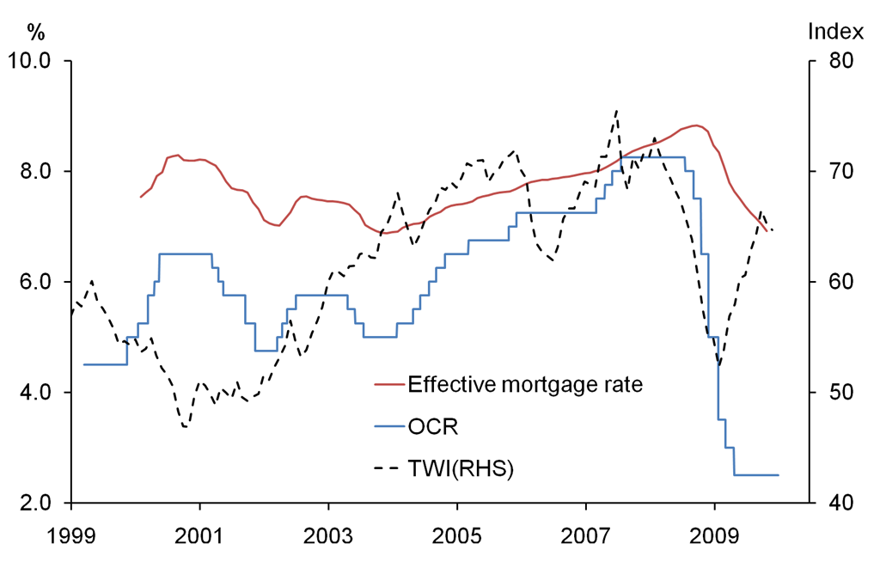
Source: RBNZ

The grass is not always greener
For all the difficulties we faced, as we look back, we can see that alternative monetary policy frameworks would not have provided the flexibility that we had to navigate these waters, and may in fact have made it harder to maintain price stability while avoiding unnecessary volatility in the wider economy. This is particularly clear if we think about policy approaches that target the exchange rate in one way or another.

Consider an ANZAC dollar. The NZ dollar has fallen by over 10 percent against the AU dollar since 2006, a period in which Australia experienced an unprecedented minerals boom and very strong growth. If our currency had been pegged to the AU dollar, New Zealand’s exchange rate to the rest of the world would have been higher, interest rates would have risen three times already, and our recession would probably have been deeper. The argument is even stronger for other currencies, such as the US dollar. Australia and New Zealand are not the same, but we are far more similar to each other than to Europe or the US. If our currency had been pegged to the US dollar over the past decade, interest rates would have been lower for longer in 2003 and 2004, exacerbating the housing boom (figure 3). Some of the challenges of a currency union can now be seen in Euro area economies such as Ireland, Greece and Spain, where monetary policy settings have been unable to lean against unsustainable domestic booms, or against the deep recessions that followed.

Figure 3: Policy interest rates in NZ, the US, and Australia
Source: Bloomberg

Figure 4: GDP growth in Euro area economies
Source: DataStream

Singapore’s monetary policy regime is sometimes pointed to as an alternative to inflation targeting that has maintained stability in the currency while achieving a track record of low and stable inflation. Over the past two years, of course, this has not been the case, with inflation approaching 8 percent in 2008 and prices falling in 2009. Over a longer period, it does appear that Singapore has generally managed to guide its exchange rate to keep inflation stable. But a range of special factors made this possible – Singapore’s extraordinarily high trade ratio, its large stock of domestic savings and foreign exchange reserves, and a range of supplementary stabilisation instruments and capital controls. In particular, in New Zealand, with its much larger non-traded sector, a Singaporean regime might potentially have required greater swings in the exchange rate than we actually saw to achieve similar inflation outcomes.

Global policies, the tax system and financial stability also matter
A lesson from this period is that while monetary policy can always achieve price stability, whether this occurs in the context of balanced growth also depends on other factors. As the housing boom has shown, these factors include global policy settings and the structure of the tax system.

Looking back over two years of crisis, perhaps the key lesson is that financial stability cannot be ignored when thinking about macroeconomic stability and the conduct of monetary policy. We’ve been reminded that financial system developments have the potential to complicate monetary policy enormously, and that stable prices do not guarantee a sound and efficient financial system – well-functioning financial markets and soundly managed institutions which make decisions based on a long-term outlook for earnings. In some economies such as the US, financial system dysfunction during the crisis rendered the standard monetary policy tool partially or wholly ineffective as spreads blew out and policy rates hit the zero lower bound. We, too, have had to take into account movements in financial market spreads and credit rationing in our policy deliberations over the past year, to an extent we would not have envisaged a decade ago. And the crisis has shown what enormous macroeconomic damage can result if financial market participants do not adequately price and manage financial system risks.

- Stabilising the Economy in the Future

Inflation targeting has proven to be a monetary policy framework that combines the discipline of focus that is needed to ensure a stable level of prices, with an operational flexibility that enables the economy to better cope with a wide range of shocks. But as we have seen, it has not eliminated economic imbalances or liberated central banks from difficult tradeoffs. Can we do better, and can those tradeoffs be made easier in future?

We know that the difficulty of our job ahead will in part depend on policy choices made by the major global players as they exit from current stimulatory policy settings. As the world emerges from recession, central bankers around the world are weighing the need to provide ongoing support for a very fragile recovery against the need to be ready for more normal conditions. This will be yet another delicate balancing act, made more complex in economies like the US by the need to unwind ‘quantitative easing’, and other unconventional policy support measures. At the same time, choices will need to be made about when to withdraw fiscal stimulus. Unlike the synchronised policy easing that we saw in late 2008, the removal of stimulus will occur at different times in different parts of the world, reflecting different recovery paths. Australia has already embarked on the exit road, the United States and Europe are still at the door.

How deftly this process of normalisation is handled will be crucial to whether the global economy recovers in a balanced way, and how stable recovery is likely to be in New Zealand. If US monetary policy settings remain too easy for too long, and if exchange rates in China and the big surplus economies remain low even in the face of a dramatically improved economic outlook, we will risk facing conditions similar to those during the years leading up to the crisis: abundant global liquidity searching for returns in the wrong places, feeding unsustainable asset booms and growing economic imbalances. Against this is the risk of a slower, more fragile recovery. It will be some years before we can judge how appropriate this normalisation has been.

The difficulty of our job will also depend on the wider domestic policy context. In particular, achieving both low inflation and balanced growth is considerably easier in an environment of fiscal discipline, and where the tax system is neutral with respect to households’ and firms’ investment decisions. In this respect, a failure to gradually remove the recent fiscal stimulus would put added pressure on monetary policy over the coming period. We are also hopeful that the recently released report of the Tax Working Group will lead to a more efficient and even-handed tax system. Tax policy is complex and needs to meet multiple objectives. Our concerns are to minimise tax-fuelled property investment and consumption that might detract from more balanced savings and growth.

Another important part of the domestic policy context is our financial policy framework. A lot of work is being done in this space internationally. Central banks, financial regulatory bodies, the Basel Committee on Banking Supervision and the Financial Stability Board are working out ways to strengthen and improve the prudential supervision of financial institutions. This includes raising the quantity and quality of minimum capital buffers held by banks, and improving the resilience of banks to liquidity shocks. It includes measures to make banks easier to restructure and unwind should they become insolvent. Financial regulators are also working on designing a ‘macro-prudential’ architecture for bank regulation. This essentially means taking into account the impact of individual banks on the riskiness of the financial system as a whole. For example, a large systemically important bank needs larger capital buffers than a smaller player. Similarly, larger buffers may need to be built up in boom times, when banks are more vulnerable to a systemic downturn.

In New Zealand, the financial system is a lot simpler than in other parts of the OECD, and has not seen the same types of excesses. Nevertheless we have taken steps to make our banks more resilient to financial system shocks. In implementing the Basel II capital framework, we have ensured that banks’ assessment of risk is based on a ‘through-the-cycle’ approach rather than just on the period of recent growth. We have also put in place a new prudential liquidity policy for banks which is intended to make the system less vulnerable to a drying up of international funding markets, such as we saw in late 2008 and early 2009.

Can prudential instruments such as minimum capital and liquidity requirements also help monetary policy? This depends on the link between those instruments and bank funding and lending, and also between bank lending and the behaviour of housing and other asset prices. In the case of housing, the link between mortgage lending and market prices is fairly clear. What is less clear is the extent to which the instruments themselves may constrain bank lending and housing demand in an emerging boom.

At this stage, we believe that the new liquidity policy and in particular the Core Funding Ratio could usefully contribute to the monetary policy task by limiting the banks’ ability to fuel credit growth using cheap and plentiful short-term wholesale funding during boom periods, as was the case from 2003 to 2007. In this respect, the Core Funding Ratio could potentially act as an automatic stabiliser and reduce the required hikes in the OCR during economic upturns. The role for a macro-oriented minimum capital requirement in promoting macro-financial stability (as opposed to individual bank resilience), and also assisting monetary policy, is less clear. The relationship between capital requirements and loan pricing is highly uncertain, particularly as the large lenders in New Zealand (as elsewhere) target capital holdings well in excess of current regulatory minima.

At best, these instruments could supplement the role of the OCR, but will not fundamentally alter it. Ideally, they would change the mix of monetary conditions and take some pressure off the exchange rate. Overall monetary conditions would still need to be set appropriately to keep inflation stable.

We must also be realistic about the learning that still needs to be done in the macro-financial area. Central banks do not yet understand enough about the properties of prudential instruments to use them as an adjustable policy lever, and doing so could raise coordination issues between monetary policy and prudential policy decisions. More broadly, economists have a relatively good understanding of inflation and the real economy, but the unknowns are much greater when we try to model macro-financial variables. We still have much to learn about how price stability and financial stability outcomes move together, about the relationship of CPI and asset price inflation, and about the interplay of credit and economic activity.

As a small, flexible and full-service central bank, the Reserve Bank is in a good position to be at the forefront of progress in integrated macro-financial policy design. We have joint price and financial stability objectives and joint powers to achieve these objectives. Our prudential supervision, financial market and payments system functions provide us with useful skills and information to draw on. But we need to be cautious about what we claim to understand and what we can influence.

- Conclusions

The inflation targeting framework has performed its primary task reasonably well over two decades, achieving price stability through both good and bad times. While it has been in place, inflation expectations have remained anchored, and it has proven flexible in responding to rapidly changing economic conditions. Major alternatives that dilute the focus on medium-term inflation and target other macroeconomic outcomes would risk reducing confidence in the future level of prices and would have led to worse overall outcomes at key points over the past 20 years.

Nevertheless, price stability alone is not sufficient to ensure a stable and balanced economy. For that to work best, we need to maintain a flexible approach to monetary policy. But we also need a conducive global financial environment, and support from other domestic economic and financial policies that have a bearing on asset markets and financial leverage. We need to be realistic. The world is not ours to influence, and it is unlikely to offer us perfect conditions. But in New Zealand, we will be seeking less distortion from future tax policy, and an increased macro-orientation of prudential policy.

